Boston University

Electrical & Computer Engineering

EC463 Senior Design Project

First Semester Report

Triton

Submitted to

Ryan Lagoy
1 Silber Way
Boston, MA 02215
(617)-877-2569
rlagoy@bu.edu

by

Team 25
Sail-Nav Technologies

Team Members

Leyandra Burke lburke@bu.edu
Kevin Connell kconn7@bu.edu
Diego D’Angelo-Cosme diegodc@bu.edu
Matthew Guacho mguacho@bu.edu
Kyla Wilson kylaw@bu.edu

Submitted: 12/08/2024

Table of Contents

Executive Summary (Diego D’Angelo-Cosme) 2
1.0 Introduction (Matthew Guacho) 1
2.0 Concept Development (Kyla Wilson) 2
3.0 System Description (Kevin Connell and Kyla Wilson and Leyandra Burke) 5
4.0 First Semester Progress (Diego D’Angelo-Cosme and Kevin Connell and Kyla Wilson and Leyandra Burke and Matthew Guacho) 7
5.0 Technical Plan (Leyandra Burke and Matthew Guacho) 11
6.0 Budget Estimate (Diego D’Angelo-Cosme) 14
7.0 Attachments (Diego D’Angelo-Cosme) 15
7.1 Appendix 1 – Engineering Requirements 15
7.2 Appendix 2 – Gantt Chart (Leyandra Burke) 16
7.3 Appendix 3 – Prototype Circuit Diagram (Diego D’Angelo-Cosme) and Pinout (Kyla Wilson) 18
7.4 Appendix 4 – Other Appendices 20

(right click on Table of Contents to update fields and page numbers automatically)

Executive Summary (Diego D’Angelo-Cosme)
Sailboat Navigation and Docking Assist: The Triton
Team 25 – Sail-Nav Technologies

Maritime navigation and docking can be incredibly challenging, especially on a sailboat; there are many environmental factors and visual limitations that can prove challenging for both new and experienced sailors. Team 25 has proposed ‘The Triton’ to solve this issue. The Triton is a portable, multi-sensor system that will provide useful information to the sailor including object sensing and detection, GPS data, wind speed and direction, speed through water, and speed over ground. This will be done using an anemometer, a paddle wheel, a GPS module, and multiple stereo cameras mounted around the vessel. Many sailboats do not have sensors and rely on a sailor’s general knowledge and expertise, so this device will allow newer sailors to gain experience docking and navigating while also providing a reliable information system for those with more experience.

Introduction (Matthew Guacho)

Nautical voyages can be extremely dangerous: the margin of error is wide and the price to pay is massive. In fact, in 2023 alone, 564 people perished and 63 million dollars in damages were attributed to boating-related accidents. One of the most challenging parts of nautical activities is docking the vessel, with crowded ports and outside factors, such as wind or currents, potentially leading to accidents. Our client wishes to make a system that solves this problem: a system that aids the sailor, regardless if they are a novice or a master, in docking their vessel, as well as offering some assistance with marine voyages.
Team 25 aims to solve this problem with The Triton, a multi-sensor system designed for docking and nautical navigation. The Triton will implement multiple sensors that sense vital information during the boating experience, and send all relevant information to an iOS phone application via Bluetooth low energy (BLE). Using this information, the app will make recommendations to the user during the docking process. The system will be able to detect nearby objects, sense wind speed and direction, utilize GPS information to obtain speed over ground (the speed of a vessel over the Earth's surface), and to be able to measure the speed through water (speed of vessel in relation to the water). All of these attributes will give the sailor an in-depth understanding of the current sailing conditions, giving the sailor information that they would otherwise not have access to. Utilizing this information, the sailor can know how to react to certain situations given the current conditions, and even get recommendations as to what actions should be taken.
Team 25’s approach to creating the Triton is to make a system that is reliable, yet cost effective. There are other nautical assistance systems on the market, but they lack any real aid when it comes to docking by sail, and they can be exceedingly expensive, with some systems costing as much as 10 thousand dollars. Additionally, few systems are compatible with sailboats. The Triton will use essential sensors that can solve the docking problem in the most cost efficient way possible, as well as lasting as long as 12 hours, being able to withstand harsh weather conditions, and be used on a wide gamut of nautical vessels. Using the iOS app, the product can also expound what would be the wisest decision when it comes to docking, answering our client’s request to give sailors more knowledge to tackle marine situations. This will give the sailor a full understanding of their environment, thus giving them the information needed to effectively respond to any situation. With the ability to recommend actions as well, The Triton can help sailors of any skill level, whether they are just beginning or master voyagers.
Special features of The Triton include a full suite of sensors that read essential information, an app that can show such information and make recommendations to the user, and weigh at most 25 pounds. This ensures that anyone can use the system and that it can be easily installed, removed, and transported.

Concept Development (Kyla Wilson)

Understanding the Problem
To properly address our client’s problem, we first needed to understand the challenges faced by sailors out on the water. While no one in our group is a sailor, we all chose the project because of its unique challenges and the opportunity it gave each of us to develop our engineering skills. At the beginning of the semester, we met with our client Ryan Lagoy to understand more closely what he was hoping the result would be when he proposed this project. We walked away from that initial meeting with a handful of imperative items, and lots of information on potential creative ways to solve our problem. The most important points for us to hit after our initial meeting were:
- Wind speed and direction
- Collision avoidance and warning
- Dock vs boat detection
- Distance from dock
- Speed through water and speed over ground
- Waterproof, functional housing
From there, we were able to begin scouting parts for our prototype. We initially pulled a GPS module that would provide the date, UTC time, longitude and latitude, longitude and latitude indicators, altitude, course over ground, and speed; an anemometer that measures wind speed; a wind vane that measures wind direction; a stereo camera with object detection abilities; supplemental Bluetooth modules; and the microcontroller that would control our system. At this point, our group met and decided on our initial plan for developing our prototype. We wanted to choose a prototype concept that was feasible for our time frame but also allowed our client and professors to see the pipeline of data we were creating. We decided to focus on creating the base of our system for our prototype and to build upon the base modularly thereafter. Our “base,” we decided, would be the iPhone app communicating with the Raspberry Pi via Bluetooth low energy, and the first modules we would add for our prototype would be the Oak-D camera and the GPS module. From here, we decided to order the parts that we would use in our prototype. We ordered the GPS module, borrowed the Raspberry Pi 3b from our teammate Leyandra, and our client Ryan Lagoy kindly donated the Oak-D to us until our project is completed in the spring.
Our group was given the opportunity to go sailing on the Boston Harbor on October 30. Up until this point our group wanted to focus on sailing in open water, exiting and entering ports/harbors, and providing support for docking. However, after we went sailing, our team realized that in order to accomplish all of these tasks, we would need much more time and manpower. Because of this, we decided to rescope our project to focus on docking. To enable this change, we had to change our priorities and consequently our system design. We restructured our priorities to focus our time on these aspects, in this order:
- Bluetooth/App
- Housing
- Battery
- OAK-D camera
- Side camera sensors
- GPS
- Speed through water
- Wind speed/direction
Our first priority for our project was getting our Bluetooth communication working. This is an integral piece of our product, and without it, our sensors cannot communicate with the user. From there, our next highest priority is housing. Because this system will be mounted on a sailboat, we need to absolutely ensure that the system is secure and waterproof. Our client requested durability of IP 68 from our system, which we intend to meet. Without secure and waterproof housing, our system is at risk of failure in critical scenarios like docking. To tackle this challenge, we are using a clamp system to mount the Triton to a sailboat. The clamps will be easily adjustable and removable to allow for the portability of the system, which was another request from our client. After housing, we prioritized battery. Our client has requested 12 hours of use on a full battery charge, so we will consistently monitor our power consumption throughout our development process and add to it modularly as needed to be able to support that metric. Next, we have placed the Oak-D camera. The Oak-D camera is incredibly important for our application, allowing us to enable a live view of the front of the boat, which is often blocked during sailing by the front and main sails. It is also a stereo camera, giving us depth measurements to help avoid collisions, and supports object detection capabilities. Next, we have the side camera sensors. These will allow us to sense objects on the sides of the boat during docking and are incredibly important to support potential collision warnings and drive our main use case of docking assist. After those five, we have our additional sensors: GPS, Speed through water, and wind speed/direction. While these sensors are each very important in our context of sailing, because we rescoped our project to focus on docking we are prioritizing the components of our system that will be able to add value early on for our client, and we believe that the Oak-D stereo cameras will be the greatest sensor value-adds to our system. We also believe that these sensors can be easily added down the road.

System Design
Once we properly understood the problem we were trying to solve and identified our priorities, we moved forward with designing our solution. In our solution, we prioritized having as many components consolidated as possible. This was due to the request for easy mount and easy removal, as well as portability by our client. Similarly, our team liked the idea of having as many sensors wired as possible for lower latency, more straightforward communication protocols, and less power consumption. We built our system around the Raspberry Pi 3b, the computer we selected for the Triton. We chose this single-board computer because it has onboard memory, built-in Bluetooth, and can support the Oak-D camera. We considered an Arduino Uno microcontroller but thought that the flexibility to run different operating systems and multiple programs at once on the Raspberry Pi was worth it. From there, we will attach the GPS module, the Oak-D camera, the anemometer, and the wind vane directly to the Raspberry Pi with wires. This “central module” or “central processing unit” as we call it, will house the bulk of our system and sensors. In addition to the central module, we will have two stereo cameras mounted on the port and starboard sides of the boat. We intend to have the user mount the stereo cameras on the widest point of the vessel on either side and mount the cameras facing outward. These stereo cameras will each be made from two Raspberry Pi cameras, a Stereo Pi board, and a Raspberry Pi CM4. We considered using a Raspberry Pi 3/3B with an Arducam stereo vision hat and two Raspberry Pi cameras, but our team had trouble sourcing the hat alone, and the sets were too expensive for our budget. This will enable the Triton to perceive depth on either side of the boat in docking scenarios. it is intended to only use these cameras when the user has indicated that they are beginning to dock to conserve power. These stereo cameras will send depth data to the central module via Bluetooth low energy, which the Raspberry Pi CM4 module supports. Our system will also include a speed through water module. While sourcing a sensor that provides speed through water has proven difficult, our team is currently favoring the idea of having a paddlewheel sensor which will be mounted at the stern of the boat with a small microcontroller and Bluetooth module to offload the information to the central module. We considered using a speed transducer or a pitot tube, but the speed transducer would have been too costly to the budget, and the pitot tube would entail a substantial engineering feat and would be incredibly challenging to calibrate.

System Description (Kevin Connell and Kyla Wilson and Leyandra Burke)

The product that the team is developing is a three stage system consisting of individual sensors, a CPU, and an iOS application. The Triton will be using a variety of sensors including, the Oak-D S2 stereo camera, two StereoPis, an anemometer, a GPS module, and a paddle wheel speed through water sensor. The stereo cameras will be responsible for tracking object distances using depth perception (Figure 1).
The Oak-D camera is able to alert the user of objects detected up to 12 meters away and their approximate location relative to the ship. This is accomplished by comparing the pixel values of two different images from each of the side cameras on the Oak-D creating a depth heat map (refer to figures 2 and 3). This heat map is then further broken down into a 10x10 grid of Region of Interests (ROI). The individual ROI’s then detect the distance of objects within their view and warn the user if the object is within a certain range. Additionally, the Oak-D will be trained with an image recognition model for nautical vessels as well as common obstacles found at sea. The system will be capable of recognizing these obstacles and alerting the user to what obstacles may be in the path of their vessel. The Oak-D has a horizontal FOV of 88 degrees when calculating depth and a visual FOV of 66 degrees. In order to combat this, the system will be mounted onto a motor to allow for a greater scanning field of view as well as the ability for the camera to follow a given obstacle giving the sailor a constant view of the object which may not be visible at the helm due to the sails blocking their view.
In addition to the Oak-D camera, two Stereo Pis will be mounted on the starboard and port sides of the vessel. The Stereo Pi’s are stereo cameras like the Oak-D used to calculate the distance to objects within its view. These camera’s primary use will be during docking, giving the sailor an unobstructed view of the docking side of the vessel. In addition to this, the cameras will work in a similar manner to that of the Oak-D, providing the distance of any obstacles within their field of view and sending alerts if an object appears to be within a dangerous range. These cameras will only be operating during the docking procedure reducing the power consumption of the system as a whole.
The iOS application is an application that connects via Bluetooth low energy to the Triton, the data acquisition system. The application is written in Swift and uses Apple’s Core Bluetooth framework to enable Bluetooth capabilities. When the user opens the application, it will immediately start scanning for the Triton, and will automatically connect to the device once it is discovered. Once connected to the Triton, the iOS application displays the data sent from the Triton in a tile format (see Figure 4), updating every time new data is received. If the connection between the iOS application and the Raspberry Pi (Triton) is lost, the iOS application will automatically re-establish the connection if the Triton is powered on and in range. The UI will also update every time the connection state changes, enabling and disabling certain buttons to ensure proper use, in addition to a tile that explicitly lists the connection state.
The Raspberry Pi/Triton Bluetooth will advertise a 16-bit UUID for the iOS application to discover when scanning. The Triton will host a GATT Server that holds an array of services, one service for each sensor (i.e. the GPS Service). Each service will have an array of characteristics belonging to it (i.e. longitude, latitude, altitude characteristics belong to GPS service). The advertisement from the Raspberry Pi’s Bluetooth module should be able to be discovered from at least 30 meters away, and not disconnect from the central unless it exceeds 40 meters in distance.
The GPS module used is an Adafruit wearable global positioning system, containing a MTK3339 chipset. The GPS uses satellite signals to determine the precise location of the sailboat. The module provides a multitude of different types of data. However, the most valuable data includes the longitude, latitude, universal time, date, altitude, speed over ground, and course over ground. This is the data from the sensor that will be integrated with the iOS application and displayed for the user. The module is designed for and being used with low power consumption operating with 3.3 volts with an average consumption of 25mA when actively being used. As well as having an accuracy and refresh rate updating every second, or 1Hz, based on the outputting NMEA data, when there is a good signal. To improve the performance of the GPS it will also have an antenna attached to it to increase the signal strength by 20 to 40 dB.
The anemometer will be used to detect wind speeds of at least 40 miles per hour and obtain the wind direction. This will be attached to a pole and placed at the highest point of the housing, with a direct wired connection to the CPU. Wiring of the anemometer consists of power, ground and signal. The data will then be sent to the iOS application through the CPU’s Bluetooth communication. Similarly, the paddlewheel will collect data of the vessel’s speed through water, and will be placed at the bottom of a pole submerged in the water at the back of the boat. The signal that will output from the paddlewheel is based on the rotation speed of the paddlewheel which is proportional to the boat's speed in the water. This will utilize a Bluetooth connection to the CPU to transmit its data. Both modules will be connected throughout the ship’s voyage.
Each of the modules will be connected to a Raspberry Pi, either via a wired connection or wirelessly. The wireless modules will communicate through integrated Bluetooth modules. The Raspberry Pis will handle a majority of the computation and handling of the sensor data.

First Semester Progress (Diego D’Angelo-Cosme and Kevin Connell and Kyla Wilson and Leyandra Burke and Matthew Guacho)

The team’s progress can be well defined by two periods of work. Phase 1 can be seen as the preliminary research and scoping phase, while phase 2 can be seen as the prototype building phase.

Phase 1:
After meeting with their client, Professor Lagoy, the team began brainstorming methods and implementations based on the requirements and feedback given. The team was focused on creating a device that would be equally helpful for sailing on open water as well as docking. An initial design was created with a telescoping pole acting as the primary housing for various modules and the CPU. The team believed that the pole would allow the system to be easily portable due to its retractable nature, and would serve to allow a speed through water sensor to easily be placed in the water while also having the anemometer for wind speed and direction placed high in the air using the other end of the pole. The other modules such as a LiDAR sensor would be placed and powered separately.
There was a hesitation with this design due to the fact that the CPU would be attached to the side of the boat rather than secured on the boat. Additionally, it was discovered when the team was looking to purchase an anemometer that they need to be placed roughly 30 meters in the air to obtain accurate data. This would be impractical for a lightweight and portable pole to sustain the weight of the anemometer at that height and to be that tall. Additionally, after much research, the team was unsure what technology to use in order to detect marine objects since many of the prevailing technologies were too complex, too expensive, or too unreliable for the product that was being built. The team then met with Professor Lagoy to address these concerns, and he explained that the accuracy of the anemometer may not be critically important; the data from the anemometer will be used mostly to help the sailor dock, where general knowledge of the speed and direction of the wind are valuable and do not need to be precise. Professor Lagoy also introduced a new alternative for detecting marine objects through a stereo camera with built-in AI capabilities, the OAK-D S2.
This meeting enabled the team to continue planning with a new focus on researching the OAK-D camera as the new primary method of object detection. A new design idea was also introduced to mount the system on the metal railing on the front of the boat with the speed through water module being placed on a pole in the back of the boat. This design would enable a safer location for the CPU and would allow most of the modules to be directly connected to it. This would become the new housing design going forward.
Later, the team would go sailing with Professor Lagoy and one of his associates Kay VanValkenburgh, a trainer for blind sailors. The team would get hands-on experience seeing how a sailboat maneuvers, how the sailor’s vision may be blocked or impaired, and how little information is readily available on a standard sailboat. The team would ask Professor Lagoy and Kay various questions about important sensors and boat functions for beginners. This experience would cause the team to want to rescope their project from a dual navigation and docking system to a docking assistance system with some navigation utilities. The team decided to purchase the OAK-D S2 camera as a means of using object detection and reassessed the priority of their hardware modules and came to the following list:
- Bluetooth
- Housing
- Battery
- OAK-D camera
- Side camera sensors
- GPS
- Speed through water
- Wind speed/direction
They also made a list of the following software implementation priorities after the initial application was developed:
- Live view of the camera
- GPS/Compass/Speed Through Water information
- Warnings
  - Audio
  - Visual
- Calibration

Phase 2:
After re-scoping the project with Professor Lagoy and finalizing the materials needed the team began work creating the prototype. The prototype consisted of three parts, the mobile app, GPS module, and the Oak-D camera. Each team member began work on each aspect of the project. Leyandra worked on the GPS implementation, and Kyla completed the Bluetooth implementation with Matthew’s assistance, Kyla worked on the app and getting a connection through Bluetooth, and Kevin and Diego worked on the Oak-D distance sensing and calibration.
The GPS portion began with wiring the GPS module to the Raspberry Pi. The GPS module uses UART protocols for its data transmission. The device was wired connecting the module to the transmitter (TX) and receiver (RX) pins, as well as the ground and 3.3 volts pins on the Raspberry Pi (see Appendix 7.3 for circuit schematic and hardware pinout). Once fully wired the Raspberry Pi configuration was modified in order to access the serial console where the GPS data would be outputted in NMEA format, a standard GPS manufacturing format (see Appendix 4 figure 6 for outputted example data). After enabling the serial port to receive data, a program was written to create a serial connection to allow for the NMEA data to be outputted to the terminal rather than the serial console.
Afterwards, NMEA data was analyzed and it was decided how such information was displayed on the iOS application. The data was parsed into two different NMEA taglines, GGA and RMC. With those identifiers specific lines could be sent to their respective function and isolate the relevant data by using a stringstream to split the line into fields based on the commas. Then storing the fields in a vector made it possible to correspond the indices to the data being used such as, latitude, the third field in the GGA tagline or date, the tenth field in the RMC tagline. With this data found it is then continuously stored and deleted from a .txt file ensuring only the latest data is in the file as it repeatedly updates. This file is then used for continuous updates when transferring data via Bluetooth.
For the app, we started by referencing a Bluetooth low energy example provided by Apple. To enable the iOS application to act as a Central/GATT Client and connect to a Peripheral/GATT Server, we chose to use Apple’s Core Bluetooth Framework in Swift. We chose Swift because it is the most straightforward and capable language for iOS application development, which the client specifically requested. The first feature we added was scanning or advertising peripheral devices. We started by enabling the app to scan for all Bluetooth devices and print each identified UUID or local name to the terminal in Xcode. This ensured that the scanning was working properly. From here, the supplementary functions were added which are called when the application connects to a peripheral, disconnects from a peripheral, discovers a service, discovers a characteristic, subscribes to notifications on a characteristic, etc. At this point, we had enabled advertising and had dummy characteristics added to the GATT Server on the Raspberry Pi side, so that testing could begin. A filter was added on the scanner to search only for the Raspberry Pi (Triton). Features such as a “Connect” button, discoverability, and server characteristics were added afterward. The dummy characteristic added two to the initial value every second from the Raspberry Pi side, and the iOS app received the updated value every second when subscribed and printed the value to the iOS terminal. After this was working, small changes were made in the code such as only subscribing to the characteristics that Matthew helped implement on the Triton’s side. Finally, the UI was overhauled, adding a connection status indicator, a connect button, and a tile for each of the GPS characteristics. Once all of the GPS characteristics were implemented on the Triton’s end, a full test of the application’s UI was conducted ensuring the GPS values were properly being updated on the Triton’s end.
For the Bluetooth implementation on the Raspberry Pi (Triton) end, we decided to use BlueZ and D-Bus to enable BLE. While not ideal, Python was chosen for Bluetooth functionality since the other sensors have more thorough, capable, and straightforward APIs in Python, but we hope to transition to C in the future for lower latency and less stress on the Triton during use. We started off by finding an example that created a GATT Server and initialized an advertisement. Next, we tested the advertising, connecting, and subscribing to characteristics from the custom iOS application. From here, the 16-bit advertising UUID was changed from one that indicates a heart rate service to A3A3. Then, the services and characteristics included in the example were removed and replaced with unique 128-bit UUIDs for each item. From here, subscribing to each of the characteristics was tested by porting the old “dummy” code into each of them, so that every GPS characteristic would update once per second and send its value to the phone. Once that was working, the dummy code was replaced with real code that parses the true GPS values from a .txt file that the GPS script writes to and reads them into the corresponding characteristic (this is a temporary solution that is planned to be updated next semester).
With the Oak-D, a provided base example code was used which highlighted a specific region of interest or ROI and gave a visual heat map of the distance record within the ROI. This base code was then taken and modified to create a 10x10 grid of ROI’s which relayed the depth of any object detected within its area up to a distance of 15 meters. Furthermore the code was changed to give the user a visual feedback as to the distance of certain objects by changing the color of the individual ROIs from green to yellow to red depending on the recorded distance within the ROI. Any ROIs distances within the red range (less than 1.5 meters) are then reported to the users and the distance and time is logged to a .txt file (see Figure 5). Afterwards the visual feed was then changed to give a live feed with ROI overlay in addition to the heat map.
Getting the Oak-D to run on the raspberry pi initially proved challenging as the program required a lot of processing time to update the 100 ROI’s every frame at 30 frames a second. To counteract this a few methods were used to try and reduce the load of the Oak-D on the system. First thing that was done was reducing the frame rate to 15 and the resolution of the feed was cut down as the live video feed of the ROIs was meant only for demonstration purposes. Additionally the ROI distance processing was smoothed to better reduce unnecessary calculations due to noise. Lastly some of the image processing and calculations were off loaded to the Oak-D itself reducing the overall computational strain on the Pi.

Technical Plan (Leyandra Burke and Matthew Guacho)

December 11, 2024 - December 31, 2024
Completion and Refinement of Preliminary Design and Preliminary Product

Task 1: Final Housing Design
Housing will be fully designed and integrated with all sensor types. The housing
and sensor choices have continuously changed throughout the semester and there is now full consensus on what is being used. This includes a CAD model of the mounting and housing components with defined materials and specifications based on theoretical calculations of, weight restriction of 25 lbs, and material cost and usage.
Lead: Leyandra Burke

Task 2: Power Budget
A power budget will be created with all current sensors and devices in order to
track what batteries need to be purchased and how much consumption of power is happening in the system. The power budget will be tested by including calculations of power usage of at least 12 hours.
Lead: Diego D’Angelo-Cosme
Assisted by: Kevin Connell

Task 3: GPS Data Retrieval Refinement
The current process of data retrieval from the GPS will be converted to a more efficient and processable form. The current system retrieves data in a storage intensive and non-ideal way making the updating to the Bluetooth file slower that will be changed. The system is currently updating the GPS IPC file every second. When transitioning to a new, more efficient process, this will be tested by ensuring the update rate can consistently be more frequent to allow for lower latency. The update rate should be at least once every ½ second.
Lead: Kyla Wilson
Assisted by: Matthew Guacho

January 1, 2025 - January 31, 2025
Intermediate Design and Subsystem Development

Task 4: Acquire All Housing Materials and Sensors
All materials and sensors will be purchased and delivered, ensuring all parts of the
project have every piece needed to complete the task. All materials, sensors, and miscellaneous things must not exceed the budget of $1000.
Lead: Kevin Connell
Assisted by: Diego D’Angelo-Cosme, Matthew Guacho

Task 5: iOS Application Skeleton Development
The iOS app will have a layout of the full user interface developed for each of the
components of data expected to be received from the Raspberry Pis. This will be
tested by usability testing received by potential customers feedback with an
approval rating of at least 85%.
Lead: Kyla Wilson

Task 6: Completion of Mounting Clamps
The mounting clamps will be completed and have detachable hinges for
connection to the housing structures. The mounting clamps will be tested by their
range of adjustability with diameter between 1” and 5” and can uphold a weight
of 10 lbs per clamp.
Lead: Leyandra Burke

February 1, 2025 - February 28, 2025
Finalization of Component Implementation

Task 7: Motorized Camera Stand
The Oak-D will be placed on a motorized stand to increase the field of view
(FOV). This will be tested by comparing the current FOV of 88 degrees for horizontal depth and 66 degrees visual with the projected FOV increased by a full range of 180 degrees and a 50% increase of FOV on both sides of the camera.
Lead: Leyandra Burke
Assisted by: Kevin Connell

Task 8: Media Transfer with Bluetooth
The live video feed from the Oak-D camera will be able to transfer through Bluetooth on the Raspberry Pi to the iOS application with a latency of 100 ms.
Lead: Kyla Wilson

Task 9: Sensor Circuit Implementation
Design and implementation of each sensor module’s circuit with secure and reliable connections. Include three different circuit schematics for each of the different modules.
Lead: Diego D’Angelo-Cosme
Assisted by: Kevin Connell

Task 10: Sensor Modules Completed with Parsed Data
All sensor modules will be wired and output their respective data in an easily readable format for transferring through Bluetooth. All modules will be optimized for working with each other, being tested at an updating rate of 1 second.
Lead: Matthew Guacho
Assisted by: Leyandra Burke, Diego D’Angelo-Cosme

Task 11: Train Oak-D Camera
The Oak-D will be trained with the relevant datasets to recognize common obstacles encountered during sailing. The Oak-D will be able to recognize objects within 15 meters with an accuracy of 80% and an accuracy of 65% for objects detected at a distance of 25 meters.
Lead: Diego D’Angelo-Cosme
Assisted by: Kevin Connell

March 1, 2025 - April 1, 2025
Integrating Components and Initialization

Task 12: Integration of Sensor Data with iOS Application and Bluetooth
The iOS app and the Bluetooth connectivity of the Raspberry Pi with all the sensor module data will have a consistent and reliable connection for distances of at least 35 feet. Data transfer and processing speeds will be tested to maintain a range between 1.6 GHz to 2.5 Ghz.
Lead: Kyla Wilson
Assisted by: Leyandra Burke, Diego D’Angelo-Cosme, Kevin Connell, Matthew
Guacho

Task 13: Integration of All Components with Housing
All components will be integrated and placed within the housing and have the capability to be mounted on different types of sailboats. The fully integrated system should have an IP68 waterproof rating and be able, weigh less than 25 lbs and be able to fit in an average sized backpack.
Lead: Leyandra Burke
Assisted by: Kyla Wilson, Diego D’Angelo-Cosme, Kevin Connell, Matthew
Guacho

Budget Estimate (Diego D’Angelo-Cosme)

Item | Description | Donated | Cost
1 | OAK-D Camera (1) | Y | $250
2 | GPS Module (1) | N | $25
3 | StereoPi (2) | N | $120
4 | Anemometer (1) | N | $150
5 | Speed Transducer (1) | N | $110
6 | Battery Packs (3) | N | $200
7 | Raspberry Pi 3B (1) | Y | $30
 | Total Cost |  | $885

The OAK-D camera was donated to the team by their client, due to its high cost. This camera is vital, though, because of its AI capabilities with object detection. A major challenge that was encountered when attempting to create a viable implementation of object detection was that other technologies, such as radar and LiDAR, were either more expensive or more complex with little functionality. This camera detects objects in an easy-to-implement manner and for a price that is still cheaper than other technologies. The other cost amounts listed take into account if multiple of the same module are necessary. For example, the battery packs are listed as $100, but this budget estimate is for all three batteries, not a single one.

Attachments (Diego D’Angelo-Cosme)

Appendix 1 – Engineering Requirements

Team #25 Team Name: Sail-Nav Technologies
Project Name: The Triton

Requirement | Value, range, tolerance, units
Data Collected | speed through water, speed over ground, wind speed, wind direction, object detection, GPS
Battery Life | 12 hours
GPS Accuracy | <20 meters
Total Weight | <25 lbs
Object Detection Range | 1 ≤ x ≤ 12 meters
Data Refresh Rate | 1 second
Weatherproof Rating | IP68

Appendix 2 – Gantt Chart (Leyandra Burke)

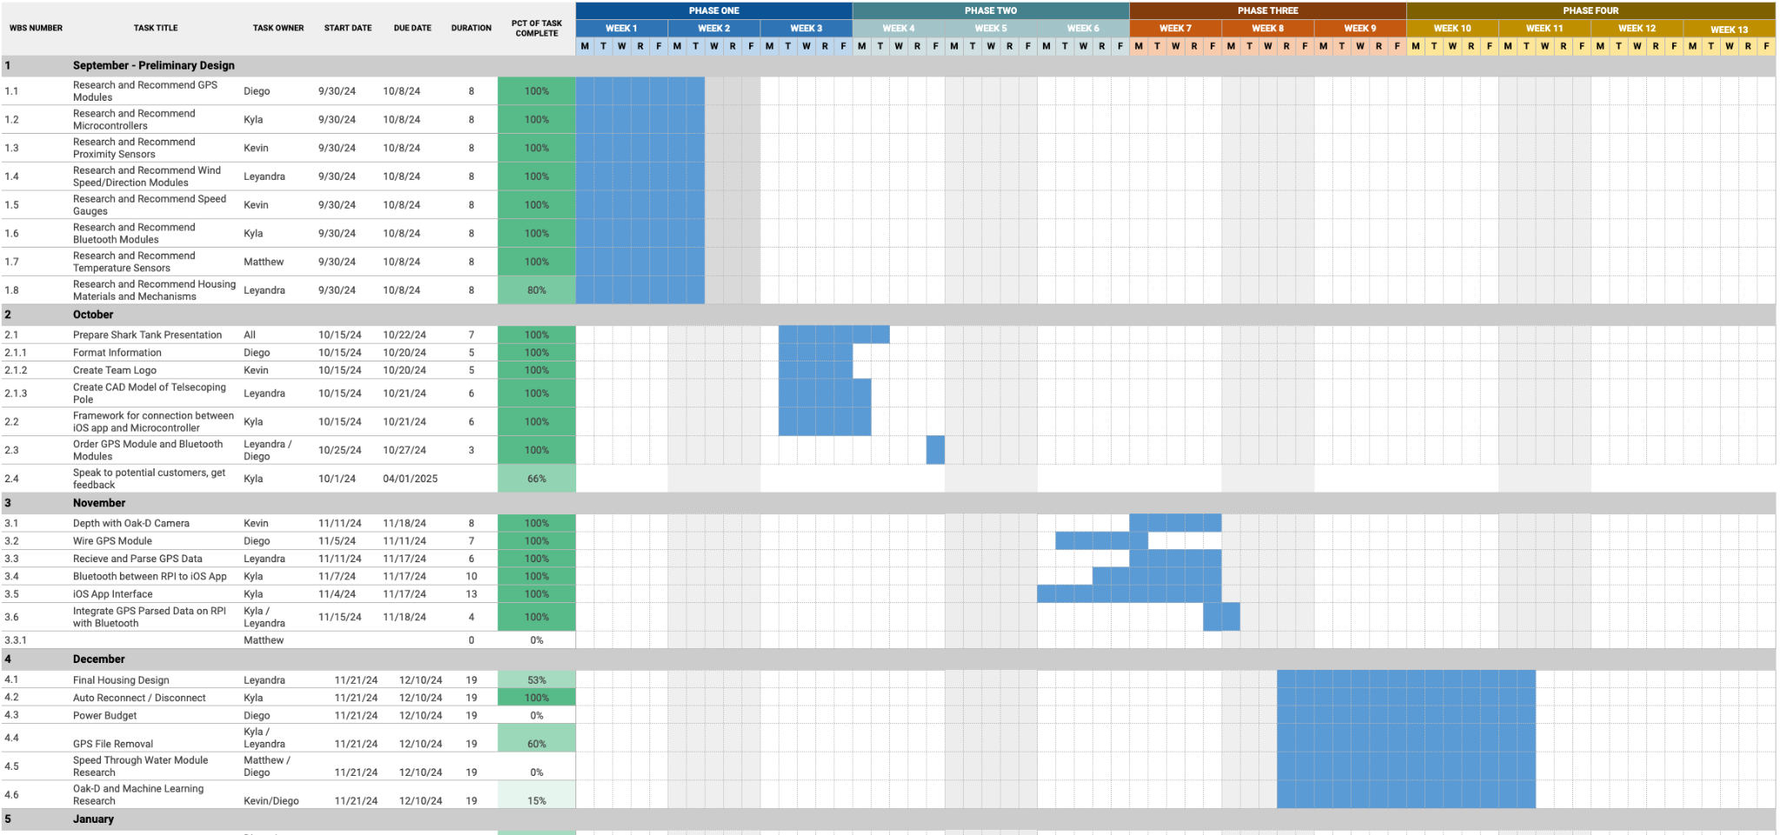
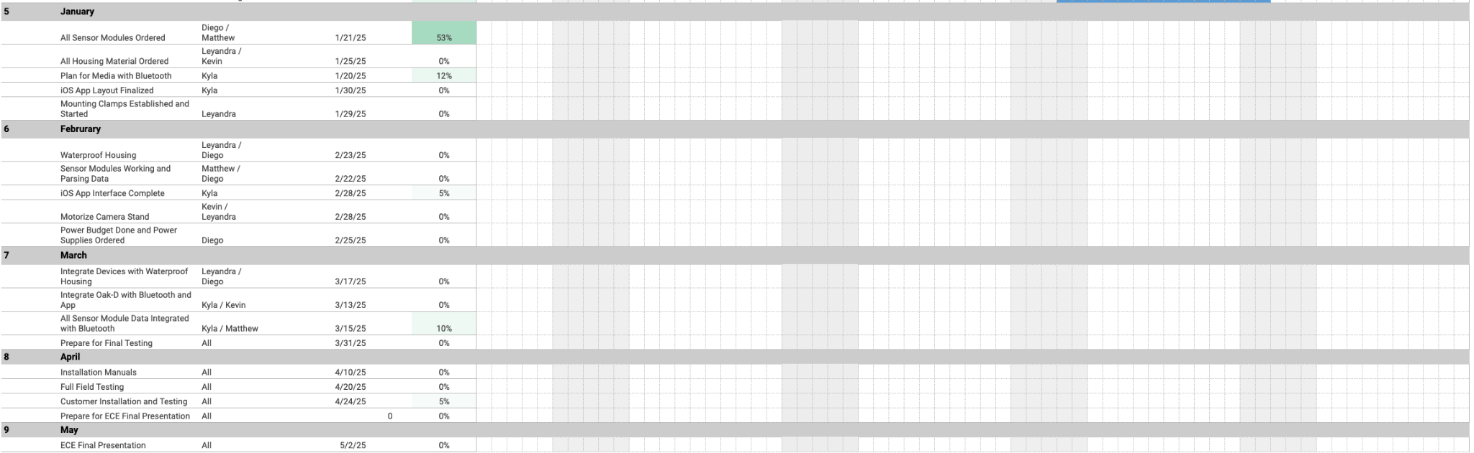

Appendix 3 – Prototype Circuit Diagram (Diego D’Angelo-Cosme) and Pinout (Kyla Wilson)
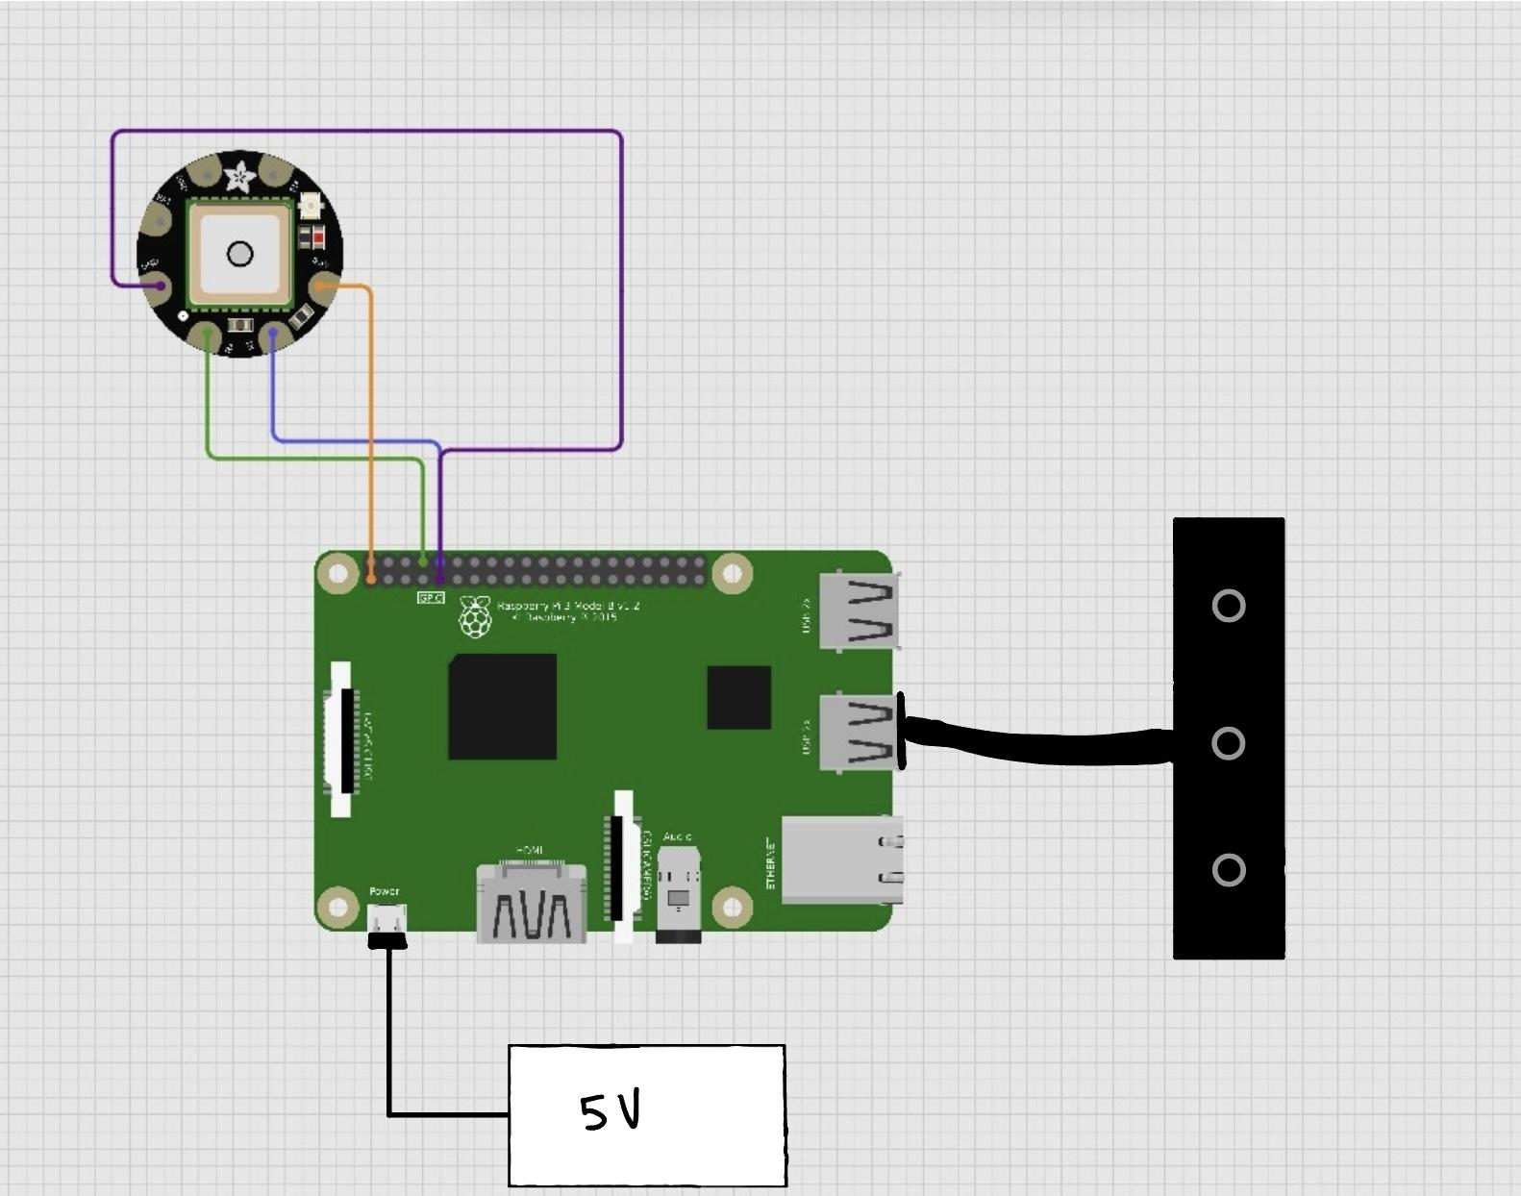

Hardware Pinout
Raspberry Pi | Peripheral
Pin 1, 3.3V | GPS 3.3V
Pin 9, GND | GPS GND
Pin 8, TX | GPS RX
Pin 10, RX | GPS TX
USB Port | OAK-D

Appendix 4 – Other Appendices

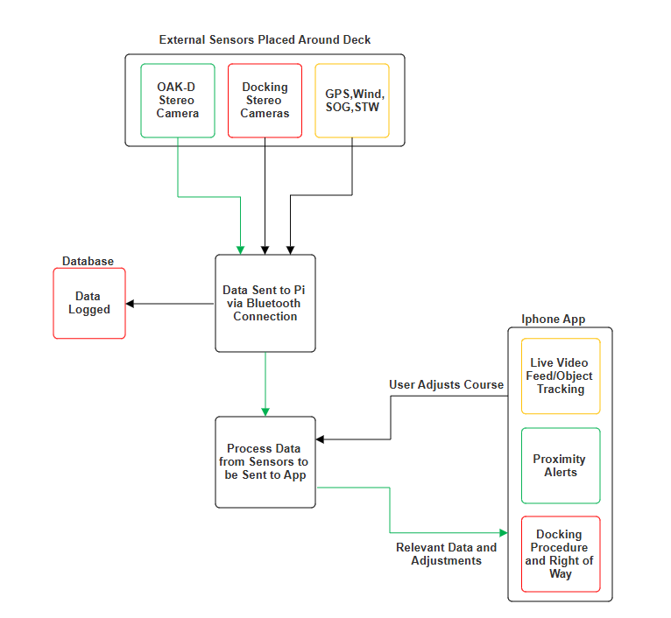
Figure 1. Block Diagram of the Triton. Blocks highlighted in green, yellow, and red indicate systems currently operational, currently being worked on and systems to be worked on in the future respectively
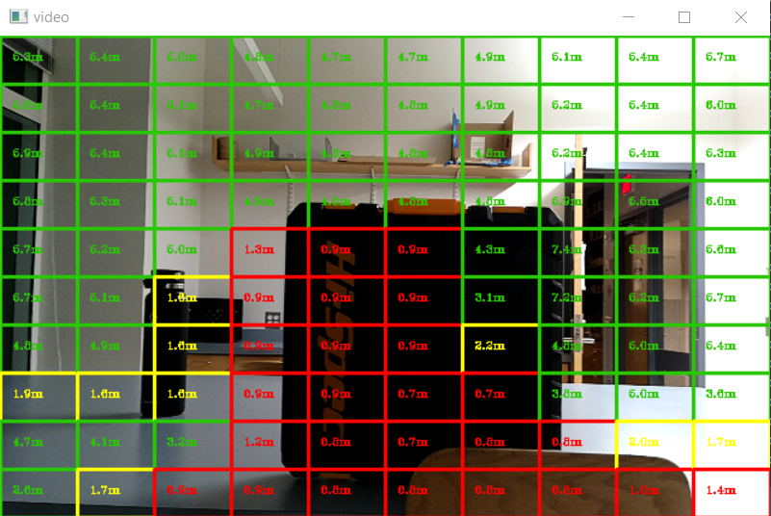
Figure 2. Live video from the Oak-D central camera with ROI overlay

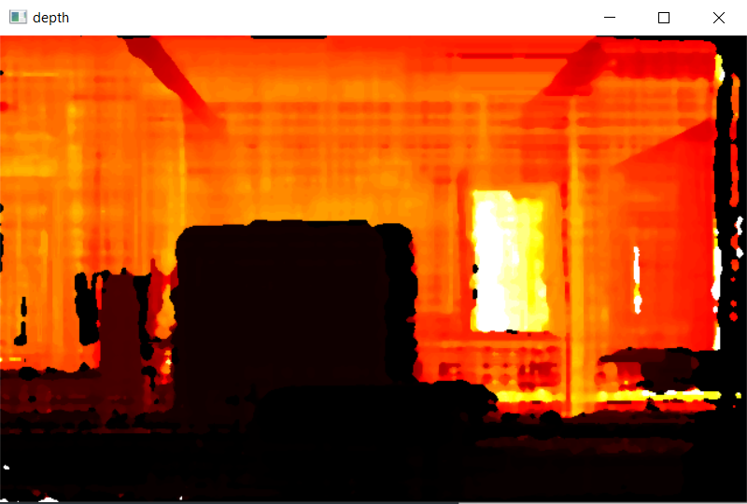
Figure 3. Heat map constructed from the stereo cameras of the Oak-D with darker and lighter sections representing a greater and lesser pixel disparity respectively

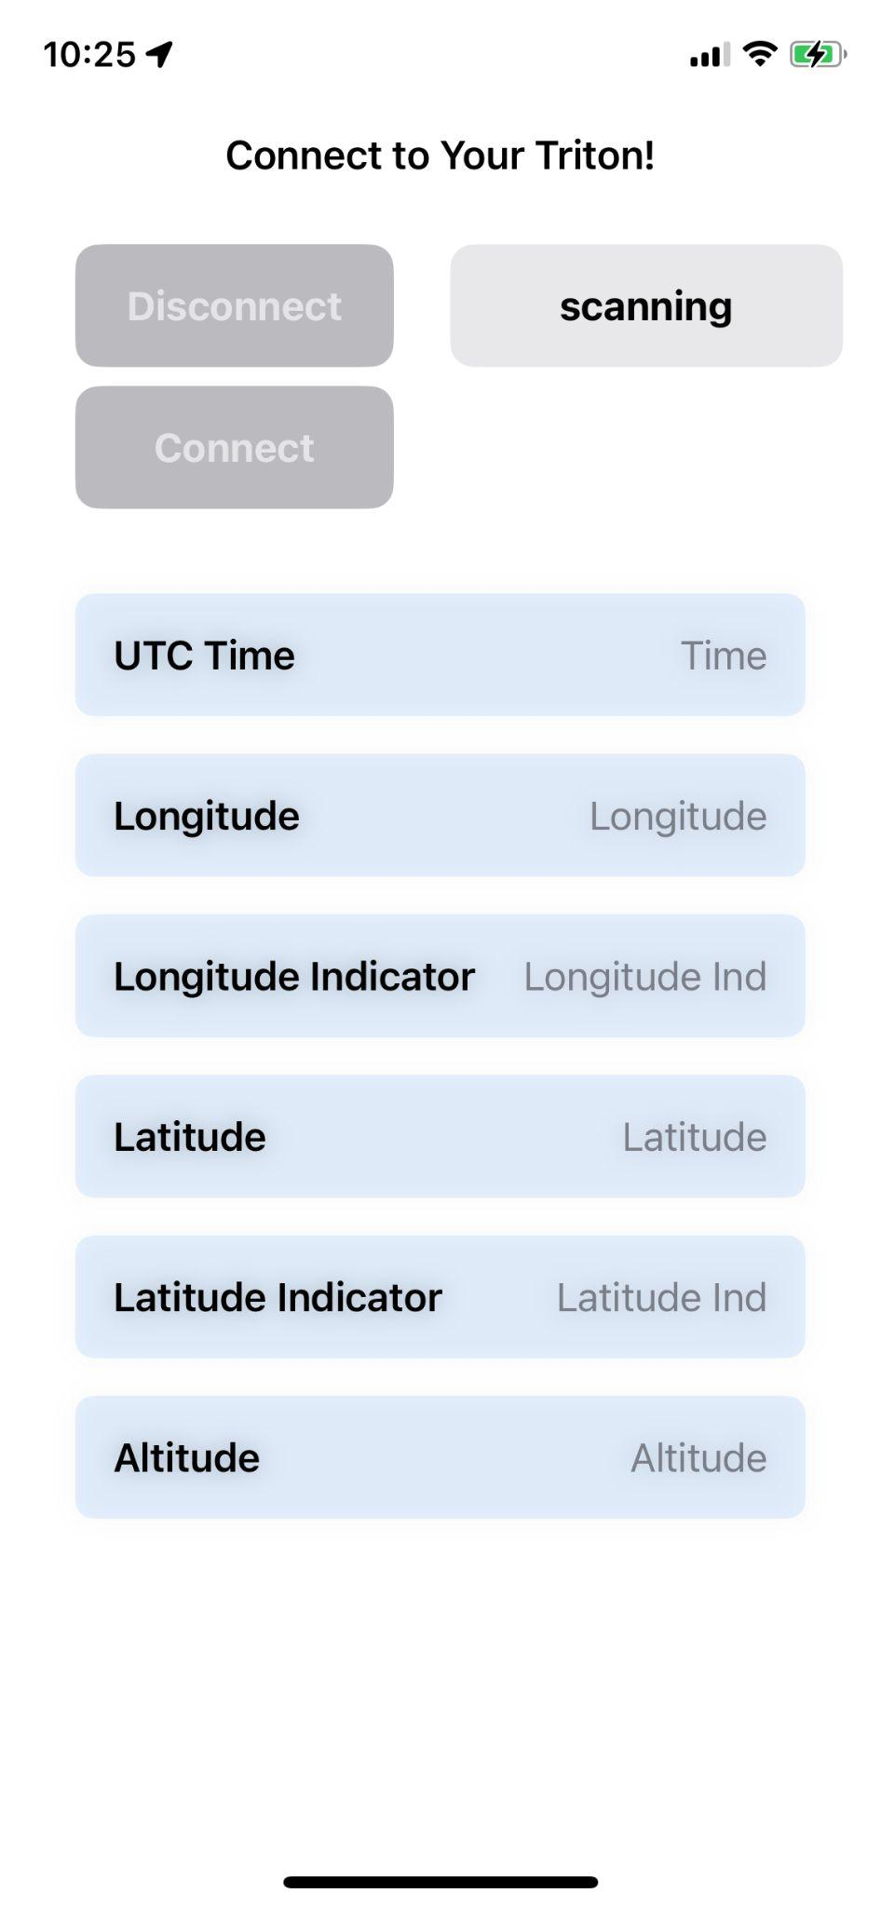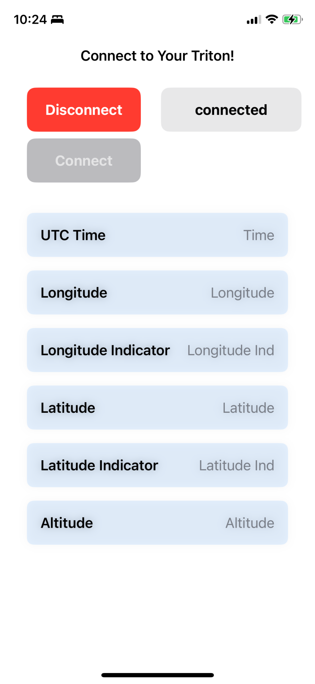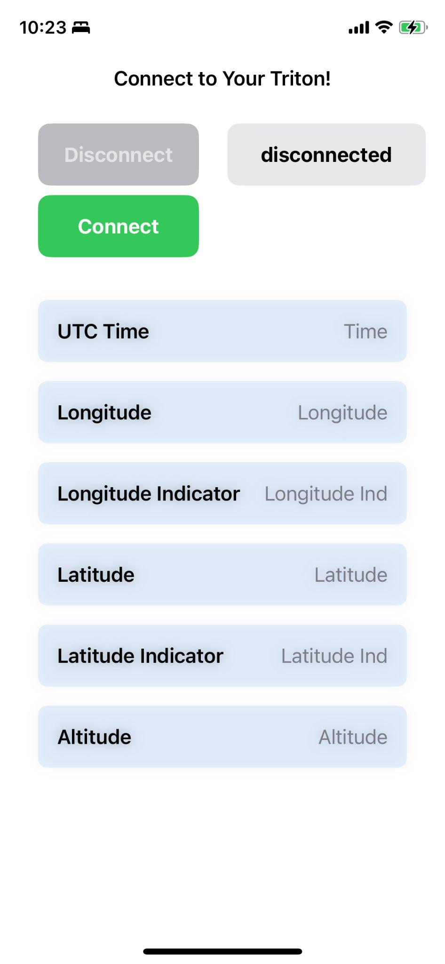

Figure 4. Representations of the iOS application’s user interface during different connection states

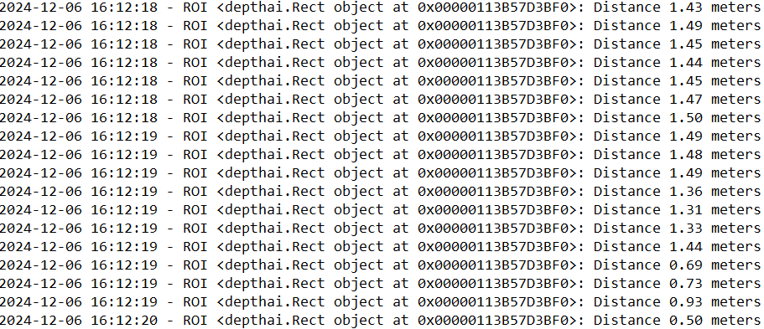
Figure 5. Text file output of objects detected within a 1.5 meter range and their respective ROI position and time recorded

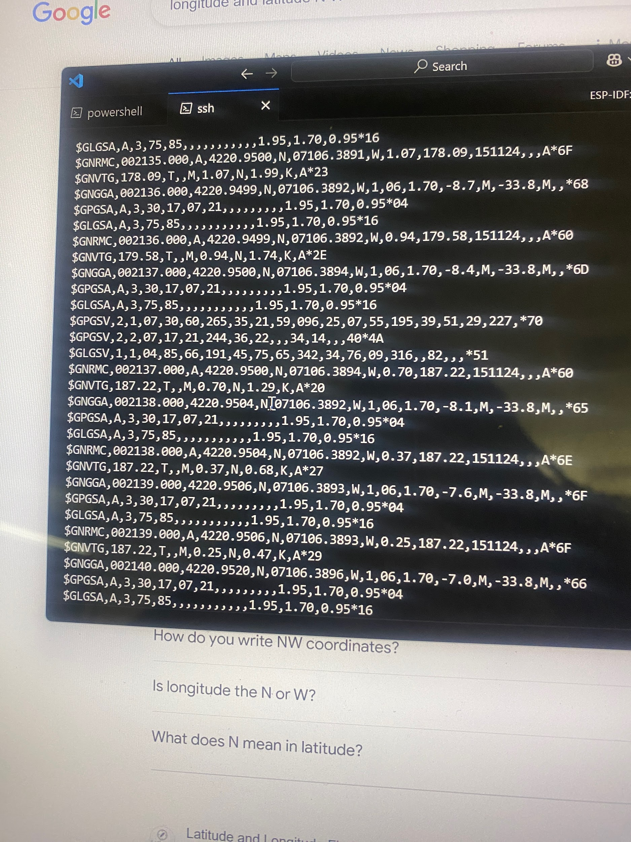
Figure 6. NMEA Data Outputted by GPS Module

